Week 4 Lab work

Task 1
Screenshots of the test code in different scenarios
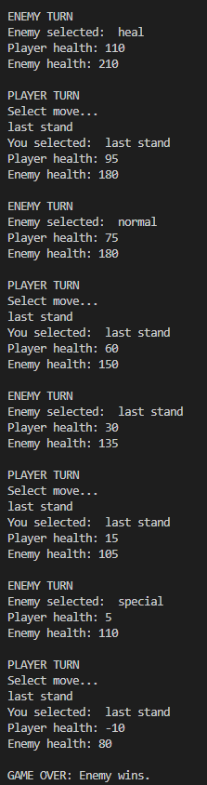
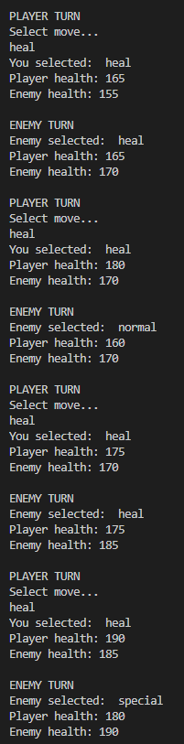
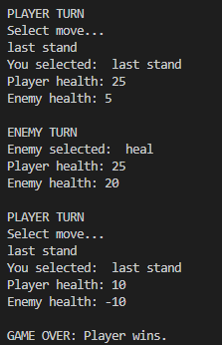
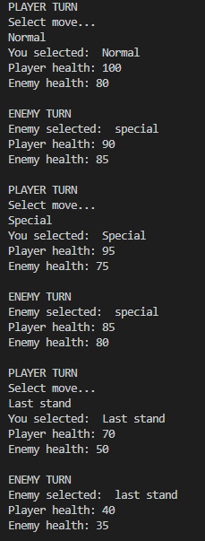
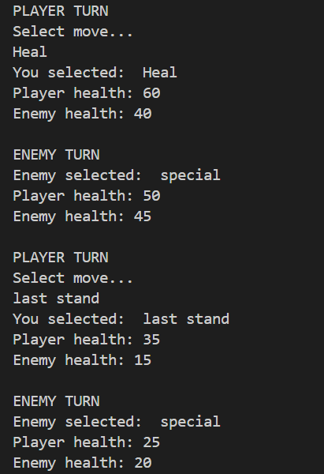
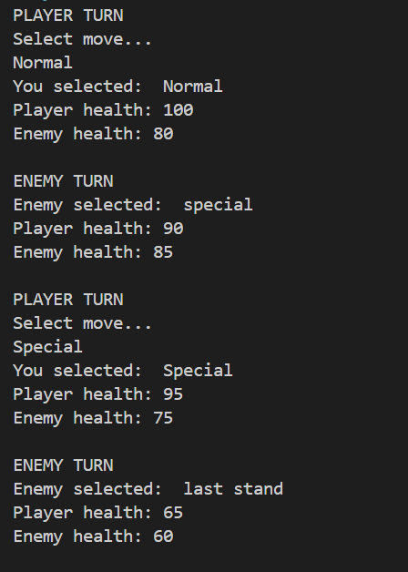
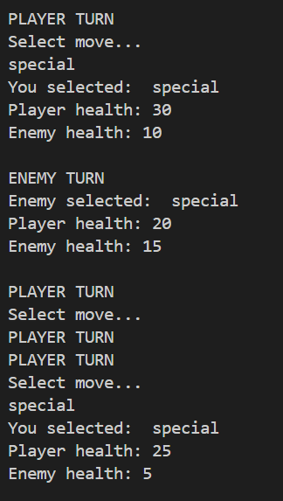
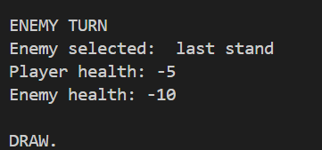
Scenario: Draw Scenario: Player wins Scenario: Enemy wins
Since this game took a long time, I have only provided the first and the last outcomes of the game.

Task 2 and 3
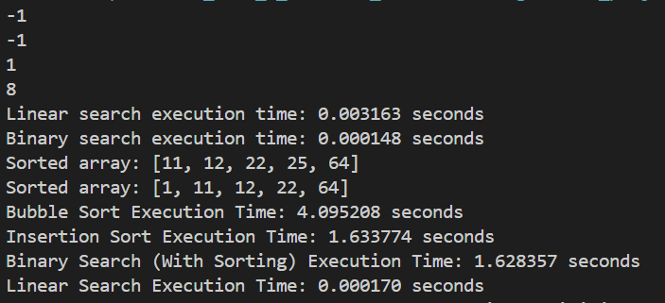
Array size was 1000

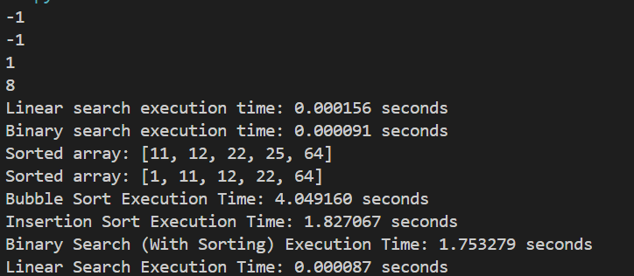
Array size is 50
As it can been seen the binary search performs better than the linear search when it comes to bigger datasets. In the first test case we used an array size of 1000 and the binary search only took 0.000148 seconds while the linear search took 0.003163 seconds, this demonstrates the difference in performance between the two searching methods. However, Binary Search requires the array to be sorted first, increasing the total time when sorting is included. For the array of 1000 elements, the bubble sort took 4.095 seconds, while the insertion sort took 1.634 seconds. Overall, Binary Search is the most efficient search algorithm for sorted data, and Insertion Sort outperforms Bubble Sort for sorting tasks.

TASK 4
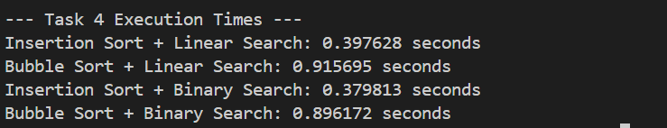

The results show that Insertion Sort combined with Binary Search performs the best, with the lowest execution time of 0.379813 seconds. This combination is faster because Insertion Sort is generally more efficient than Bubble Sort, performing fewer swaps and comparisons when sorting the data. Additionally, Binary Search is more efficient than Linear Search because it repeatedly divides the search space in half, resulting in a time complexity of O(log n) compared to O(n) for Linear Search. As a result, combining a faster sorting algorithm with a more efficient searching algorithm leads to the best overall performance. In contrast, combinations that include Bubble Sort take longer due to its less efficient sorting process.

